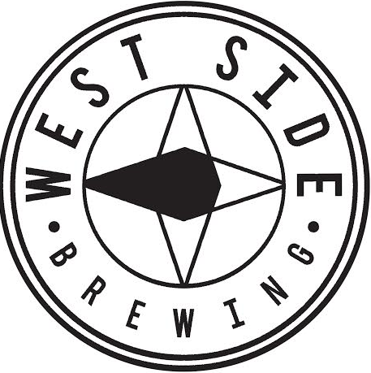
WSB Homebrew Competition - Entry Form

West Side Brewing 2nd Anniversary Homebrew Competition

Awards for Homebrew Competition
Best of Show: 1st Place Recipe brewed by WSB beer named by winner + $100 Gift Card, 2nd Place Shadow WSB’s Head Brewer with Lunch + $50 Gift Card, 3rd Place $20 Gift Card

BREWER INFORMATION (complete one form for each entry):
Name(s) Address City, State, Zip Phone Number Email Address Brew Club Name (Optional):
TARGET BEER STYLE:

BEER DESCRIPTION: (Give the judges a SHORT description of your beer)

BEER NAME: Optional

ENTRY DETAILS:
- Only non-commercially brewed beer
- 100 maximum entries for the competition
- Must be 21 or older
- 2 - 12 oz bottles per entry
- No larger, flip-top, corked or wine bottles
- De-label bottles, no writing on caps
- Complete the 2 bottle tags on page 3 of this form
- Rubberband 1 tag to each bottle
- Fold up & Rubberband this entry form to 1 bottle
- Deliver the 2 bottles to bartender during drop off hours
- Entries will be judged by BJCP judges and local professional brewers in a closed session
- Judge sheets and awards will be mailed if not claimed at WSB’s 2nd anniversary weekend.

ENTRY DROP-OFF:
Drop-off times:
Mon-Thurs 4-6 PM
Drop-off dates:
May 7th to June 18th
Bottles received after June 18th will not be judged or returned
Drop-off locations:
- West Side Brewing
3044 Harrison Ave.
Cincinnati, OH 45211

Have a question?
Email kurtis@westsidebrewing.com

2019 WSB Homebrew Competition
Your beer will be judged by the current style guidelines for the one specific BJCP category you list on the entry form.
Note: Two new Provisional Styles added for competitions in 2018 are listed below; Burton Ale 17A & New England IPA 21B. If you are entering one of these styles clearly state it on the form and the labels.
AMBER/RED/BROWN | 2. | INTERNATIONAL LAGER | IPA/PALE | 1. | STANDARD AMERICAN BEER
 |  | 2B International Pale Lager |  |  | 1A American Light Lager
 | 3. | 2C International Dark Lager  CZECH LAGER |  |  | 1B American Lager  1C Cream Ale
 |  | 3C Czech Amber Lager  3D Czech Dark Lager |  | 2. | 1D American Wheat Beer  INTERNATIONAL LAGER
 | 6. | AMBER MALTY EUROPEAN LAGER |  |  | 2A International Pale Lager
 |  | 6A Marzen  6B Rauchbier  6C Dunkles Bock |  | 3. | CZECH LAGER  3A Czech Pale Lager  3B Czech Premium Pale Lager
 | 8. | DARK EUROPEAN LAGER  8A Munich Dunkel |  | 4. | PALE MALTY EUROPEAN LAGER  4A Munich Helles
 | 9. | 8B schwarzbier  STRONG EUROPEAN BEER |  |  | 4B Festbier  4C Helles Bock
 |  | 9A Doppelbock |  | 5. | PALE BITTER EUROPEAN BEER
 | 11. | 9B Eisbock  BRITISH BITTER |  |  | 5A German Leichtbier  5B Kolsch
 |  | 11A Ordinary Bitter |  |  | 5C German Helles Exportbier
 |  | 11B Best Bitter  11C Strong Bitter |  | 10. | 5D German Pils  GERMAN WHEAT BEER
 | 13. | BROWN BRITISH BEER  13A Dark Mild  13B British Brown Ale |  |  | 10A Weissbier  10B Dunkles Weissbier 10C Weizenbock
 | 14. | SCOTTISH ALE  14A Scottish Light |  | 12. | PALE COMMONWEALTH BEER  12A British Golden Ale
 | 15. | 14B Scottish Heavy  14C Scottish Export  IRISH BEER |  | 18. | 12B Australian Sparkling Ale  12C English IPA  PALE AMERICAN ALE
 | 17. | 15A Irish Red Ale  STRONG BRITISH ALE |  |  | 18A Blonde Ale  18B American Pale Ale
 |  | 17A British Strong Ale |  | 21. | IPA
 |  | 17A Burton Ale (Provisional Style)  17B Old Ale |  |  | 21A American IPA  21B Specialty IPA
 | 19. | 17C Wee Heavy  17D English Barleywine  AMBER & BROWN AMERICAN |  | 22. | (Belgian, Black, Brown, Red, Rye, White)  21B New England IPA (Provisional Style)  STRONG AMERICAN ALE
 |  | 19A American Amber Ale  19B California Common 19C American Brown Ale |  |  | 22A Double IPA  22B American Strong Ale 22C American Barleywine
BELGIAN | 23. | EUROPEAN SOUR ALE | PORTER/STOUT | 9. | STRONG EUROPEAN BEER
 |  | 23A Berliner Weisse  23B Flanders Red Ale |  | 13. | 9C Baltic Porter  BROWN BRITISH BEER
 | 24. | BELGIAN ALE |  |  | 13C English Porter
 |  | 24A Witbier  24B Belgian Pale Ale |  | 15. | IRISH BEER  15B Irish Stout
 | 25. | 24C Biere de Garde  STRONG BELGIAN ALE |  | 16. | 15C Irish Extra Stout  DARK BRITISH BEER
 |  | 25A Belgian Blonde Ale |  |  | 16A Sweet Stout
 | 26. | 25B Saison  25C Belgian Golden Strong  TRAPPIST ALE |  |  | 16B Oatmeal Stout  16C Tropical Stout  16D Foreign Extra Stout
 |  | 26A Trappist Single  26B Belgian Dubbel |  | 20. | AMERICAN PORTER AND STOUT  20A American Porter
FRUIT/SEASONAL |  | 26C Belgian Tripel  26D Belgian Dark Strong Ale |  |  | 20B American Stout  20C Imperial Stout
 | 29. | FRUIT BEER  29A Fruit Beer  29B Fruit and Spice Beer
 | 30. | 29C Specialty Fruit Beer  SPICED BEER
30A Spice, Herb or Vegetable Beer
30B Autumn Seasonal Beer 30C Winter Seasonal Beer

Rubber band 1 tag on each bottle
Name: Phone: Email: Competition Group:
AHA/BJCP Category:
Beer Name: Optional
Rubber band 1 tag on each bottle
Name: Phone: Email: Competition Group:
AHA/BJCP Category:
Beer Name: Optional

